ECA18 – OPTOELECTRONICS AND OPTICAL COMMUNICATION
CO3 SCENARIO-BASED ASSIGNMENT REPORT
Design and Performance Evaluation of an Integrated Photodetection,
Imaging, Biomedical Sensing and Display System

Abstract:
This report presents a practical design proposal for an integrated optoelectronic platform intended for wearable health monitoring, automotive LiDAR, image capture, face recognition, ultraviolet sensing and compact display systems. The design is developed by matching each application to the detector speed, sensitivity, noise, power and integration needs. The given numerical values are used to calculate the PPG photocurrent change, LiDAR photocurrent, low-light signal-to-noise ratio, detector transit-time bandwidth and photovoltaic maximum power.
The recommended approach uses a silicon PIN photodiode for low-noise PPG and general imaging, an avalanche photodiode (APD) where additional sensitivity is needed for LiDAR, CMOS imaging for compact and low-power camera functions, flexible photovoltaic cells for auxiliary wearable power, and MicroLED as a strong candidate for high-brightness near-eye displays. MATLAB-style numerical modelling is included to show photocurrent scaling and an illustrative SNR trend. Parameters not supplied in the scenario are stated as assumptions rather than treated as measured results.

Introduction:
Optoelectronic systems convert light into electrical signals or use electrical energy to generate light. Their performance depends on the wavelength, received optical power, detector responsivity, noise, response time and the way the components are connected to the rest of the system. A single detector type is not ideal for every application. For example, a wearable PPG sensor needs stable measurement of small changes in reflected light, while LiDAR needs a fast receiver that can detect weak returning pulses.
The purpose of this report is to propose an integrated platform and justify the choices using the scenario data. The work covers detector selection, noise and SNR, speed, photovoltaic energy harvesting, CMOS/CCD sensors, emerging displays, application-specific sensing and simulation. Where the question does not provide enough information for a unique numerical answer, the assumption and its limitation are clearly identified.

Application Requirements :
Application | Main requirement | Design implication
Wearable PPG | Detect small changes in reflected red/green/NIR light with low power | High useful responsivity, low noise, stable analogue front end and moderate bandwidth
NIR spectroscopy | Measure wavelength-dependent light absorption or reflection | Wavelength-matched detector, optical filters and calibrated signal processing
Automotive LiDAR | Detect short, weak optical pulses with accurate timing | Fast PIN/APD receiver, low capacitance, suitable gain and high-bandwidth electronics
Face recognition | Capture clear images in visible or NIR illumination | CMOS sensor, adequate pixel count, low-light performance and efficient processing
UV sensing | Measure ultraviolet radiation while rejecting unwanted visible/IR light | UV-sensitive photodiode, suitable optical filter and wavelength calibration
Wearable energy | Provide supplementary electrical power from ambient light | Flexible PV module, power management and realistic energy budgeting
AR/VR/MR display | Bright, compact image with good contrast and response | MicroLED or another display selected after checking brightness, power, size and cost

Application Requirement Statement: The platform must measure small optical variations accurately, detect weak and fast LiDAR returns, capture useful images, sense selected UV/NIR bands, support wearable power harvesting and provide a compact display interface. It must also keep noise, power use, heat, size and integration complexity within practical limits.

Photodetector Configuration

Photocurrent calculations:
Responsivity (R) is the ratio of photocurrent to incident optical power: R = Iph / P. Therefore, Iph = R × P.
PPG: Given R = 0.60 A/W and optical-power variation ΔP = 25 µW = 25 × 10⁻⁶ W.
ΔIph = 0.60 × 25 × 10⁻⁶ = 15 × 10⁻⁶ A = 15 µA.
Thus, the expected change in PPG photocurrent is 15 µA. In a real sensor, the analogue front end must separate this pulsatile change from the larger steady background signal and from motion artefacts.
LiDAR: Given R = 0.80 A/W and received power P = 3 µW = 3 × 10⁻⁶ W.
Iph = 0.80 × 3 × 10⁻⁶ = 2.4 × 10⁻⁶ A = 2.4 µA.
The calculated LiDAR photocurrent is 2.4 µA before any APD multiplication gain. If an APD with multiplication factor M is used, the approximate multiplied signal current is M × 2.4 µA, while avalanche noise also increases.

PIN and APD comparison:
Feature | PIN photodiode | APD
Internal gain | No avalanche multiplication; gain is approximately 1 | Internal multiplication provides gain M greater than 1
Sensitivity | Good when optical power is adequate and receiver noise is low | Useful for weak signals because of multiplication gain
Noise | Generally lower excess noise | Avalanche multiplication adds excess noise
Bandwidth | Can be very high with suitable area and circuit design | Can be high, but multiplication and capacitance affect speed
Bias | Usually lower reverse bias | Requires higher reverse bias near avalanche operation
Linearity | Often easier to maintain over the designed range | Gain and linearity require careful bias and optical-power control
Complexity and power | Simpler, usually lower power and cost | More demanding bias and temperature control
Best use in this proposal | PPG and general CMOS-compatible optical sensing | LiDAR or low-light channels when extra sensitivity is needed

Quantum efficiency, NEP and detectivity:
Quantum efficiency (η) is the fraction of incident photons that produce collected charge carriers. For a detector with responsivity R at wavelength λ, η = R hc / (q λ), where h is Planck’s constant, c is the speed of light and q is electron charge. Wavelength is not supplied, so a numerical quantum efficiency cannot be calculated without making an additional wavelength assumption.
Noise-equivalent power (NEP) is the optical power that produces a signal equal to the detector noise in a 1 Hz bandwidth, commonly expressed in W/√Hz. Lower NEP indicates better weak-light performance. Specific detectivity D* is commonly expressed in cm·√Hz/W; higher D* generally indicates better sensitivity after accounting for detector area and bandwidth. Numerical NEP and D* cannot be obtained from the supplied data because noise spectral density and active area are not given.
Dark current flows even when no useful light is present. It contributes shot noise and can reduce the ability to detect weak signals. Detector linearity matters because the output should remain proportional to light level across the expected operating range.
Design Decision 1: Use a silicon PIN photodiode for the PPG channel because it provides a simple, low-noise and low-power measurement path. Use an APD for the LiDAR/weak-light receiver when the link budget requires additional sensitivity and the extra avalanche noise and bias complexity can be managed. This application-specific selection is more appropriate than forcing one detector type to serve every function.

Noise and SNR Strategy:

SNR calculation
For signal power Ps = −22 dBm and noise power Pn = −37 dBm, SNR in dB = Ps(dBm) − Pn(dBm).
SNR = (−22) − (−37) = 15 dB.
The linear power ratio is SNR = 10^(15/10) ≈ 31.6. Therefore, signal power is about 31.6 times the stated noise power.

Noise sources and control
Noise source | Cause | Practical control
Shot noise | Random arrival of charge carriers from photocurrent and dark current | Reduce unnecessary current, choose suitable bandwidth and use adequate optical power
Dark-current noise | Random carrier generation without useful illumination | Choose a low-dark-current detector, reduce temperature if justified and shield unwanted light
Avalanche excess noise | Randomness in APD multiplication | Use only the gain needed for the link budget and select a suitable APD
Receiver/electronic noise | Amplifier, resistor and circuit contributions | Use a low-noise transimpedance amplifier, good layout and proper grounding
Ambient-light interference | Unwanted light enters the detector | Use optical band-pass filters, shielding and synchronous detection where suitable

At low optical power, dark-current and electronic noise can become comparable to or greater than the useful signal. Increasing APD gain does not always improve SNR because avalanche multiplication also increases noise. Wider bandwidth allows faster changes to be detected but admits more integrated noise; therefore, bandwidth should be no wider than the application requires.
Design Decision 2: Use optical filtering, a low-noise receiver, controlled detector gain and application-matched bandwidth. The measured SNR of 15 dB is a useful starting point, but the final design should verify SNR under changing ambient light, temperature and optical power.
Response Time and Bandwidth
The scenario gives detector transit time tr = 20 ps = 20 × 10⁻¹² s and the approximation f ≈ 0.44 / tr.
f ≈ 0.44 / (20 × 10⁻¹²) = 2.2 × 10¹⁰ Hz = 22 GHz.
The approximate transit-time-limited bandwidth is 22 GHz. This is a theoretical limit based on carrier transit time alone; the complete receiver may have a lower bandwidth because of detector capacitance, load resistance, package parasitics, amplifier bandwidth and PCB layout.
The RC time constant is τ = Rload Ctotal. A larger capacitance or load resistance increases τ and reduces bandwidth. A larger active detector area can improve optical collection but usually increases capacitance. For LiDAR, a small-area, fast detector with carefully designed optics and a high-bandwidth receiver is recommended. For imaging, pixel-level speed and readout architecture must be balanced against sensitivity and image quality.
Design Decision 3: Use a fast APD or PIN receiver selected against the required LiDAR range and optical budget, with low total capacitance and a high-bandwidth front end. The 22 GHz result is the transit-time estimate, not a guarantee of 22 GHz system bandwidth.
PV, Image Sensors and Emerging Displays:

Photovoltaic maximum power
Given open-circuit voltage Voc = 0.60 V, short-circuit current Isc = 5 A and fill factor FF = 0.75.
Maximum power is estimated by Pmax = Voc × Isc × FF.
Pmax = 0.60 × 5 × 0.75 = 2.25 W.
The estimated maximum power is 2.25 W under the conditions represented by the given values. Voc is the terminal voltage at zero current; Isc is the current at zero terminal voltage. Fill factor indicates how close the I–V curve is to an ideal rectangular shape. PV efficiency cannot be calculated without the incident optical power or irradiance and cell area.
Flexible PV can conform to a wearable surface and provide supplementary energy, but output depends on illumination, orientation, temperature, bending durability and available area. A power-management circuit and rechargeable storage may be needed. It should not be assumed that the PV alone can continuously power all wearable and display functions.

CMOS and CCD image sensors:
Feature | CMOS | CCD
Readout | Pixels commonly include local charge-to-voltage circuitry; rows/columns are read electronically | Charge is transferred through the device to a readout node
Power | Usually lower system power | Often higher clocking and readout power
Speed/integration | Fast readout and easy integration with processing circuits | Can provide uniform image quality but may require more specialised support
Noise | Varies by pixel and readout design; modern CMOS can achieve low noise | Traditionally known for good uniformity and low noise in selected designs
Pixel scaling | Well suited to dense pixels and compact sensor systems | Charge-transfer structure can complicate scaling and integration
SoC integration | Strong fit for camera-on-chip and mobile systems | Usually less straightforward to integrate with general logic
Proposed applications | Face recognition, automotive cameras and compact imaging | Specialised scientific imaging when its performance justifies the system cost

Shrinking pixels can increase resolution per unit area, but each pixel collects fewer photons and may have reduced full-well capacity. This can make low-light noise and dynamic range more challenging. Backside illumination, microlenses, efficient readout and image processing can help. For this compact integrated platform, CMOS is the preferred general-purpose image sensor.
OLED, MicroLED and quantum-dot displays:
Technology | How it works | Strengths | Limitations / suitable use
OLED | Organic emissive layers generate light when driven | Deep blacks, high contrast, fast response; thin and flexible panels are possible | Organic material ageing and burn-in risk; suitable for phones and foldable displays
MicroLED | Micrometre-scale inorganic LEDs emit light | High brightness, fast response, strong lifetime potential and good outdoor visibility | Transfer/manufacturing cost and yield remain challenging; promising for AR/VR/MR
Quantum-dot display | Quantum dots convert or emit narrow-band colours in a display stack | Wide colour gamut and high colour purity | Implementation varies; some systems need a separate backlight and are less naturally suited to foldability

Design Decision 4: Use flexible PV as auxiliary wearable power, CMOS for the principal imaging channel and MicroLED as the leading candidate for a high-brightness AR/VR/MR interface. OLED remains attractive if foldability, thinness and mature manufacturing are the main priorities. The final display decision depends on budget, size, thermal limits and the exact product target.
Biomedical and Industrial Applications (Stage 6)

Wearable PPG
A PPG sensor shines light into the skin and measures the light reflected back or transmitted through tissue. Blood volume changes with each heartbeat, causing a small change in detected light. The electronics amplify and filter this variation, then estimate pulse rate and related waveform features. The given optical-power variation of 25 µW produces a calculated 15 µA photocurrent change at 0.60 A/W responsivity. Green light is common for wrist pulse sensing, while red and NIR can be used for other measurement arrangements. The design must manage motion artefacts, skin contact, ambient light and battery use.

NIR spectroscopy
NIR spectroscopy illuminates a sample at one or more near-infrared wavelengths and measures the returned or transmitted light. Different molecules absorb light differently, so calibrated intensity ratios can provide information about sample composition. The source wavelength, detector response, optical path, filtering and calibration must be selected together. A single detector reading alone is not enough to identify a biological property reliably.

LiDAR and automotive sensing
LiDAR sends short optical pulses and detects their reflections. The time delay gives distance using d = cΔt/2. A fast detector, low-jitter receiver, narrow optical filter and suitable gain help detect weak returns. Automotive cameras can use CMOS sensors for lane, object and face-related imaging, while LiDAR provides range information. The final vehicle system should combine sensing channels and include validation for sunlight, rain, fog, temperature and eye-safety requirements.

Face recognition:
Face recognition normally uses a CMOS camera to capture a face image, followed by software that detects facial features and compares a representation with an enrolled template. NIR illumination can support imaging in low visible light when the sensor and optics are designed for that wavelength. Image resolution, focus, illumination uniformity, privacy protection and processing speed all affect performance. Photodetector selection is only one part of the full recognition system.

UV detection:
A UV sensing unit requires a detector with useful response in the target ultraviolet band and adequate rejection of visible and infrared light. Depending on the wavelength and operating environment, a UV-enhanced silicon photodiode or a specialised UV photodiode can be considered. The system needs wavelength calibration, an appropriate filter or optical window, and protection against temperature and ageing effects.
Design Decision 5: Use a PIN photodiode for wearable PPG, a wavelength-matched detector for NIR spectroscopy, an APD-based fast receiver for weak-return LiDAR where justified, CMOS cameras for face recognition and automotive imaging, and a UV-optimised photodiode for UV measurement. Application-specific optical filters and signal processing should be used rather than assuming that one optical channel can serve every purpose.

MATLAB/SCILAB Simulation and Verification
The following numerical model is intended as a simple starting point. It plots photocurrent against optical power and illustrates how SNR can vary with optical power. The SNR model uses stated assumptions for bandwidth, dark current and an equivalent electronic-noise floor; it is illustrative rather than a measured device result.

Photocurrent versus optical power:
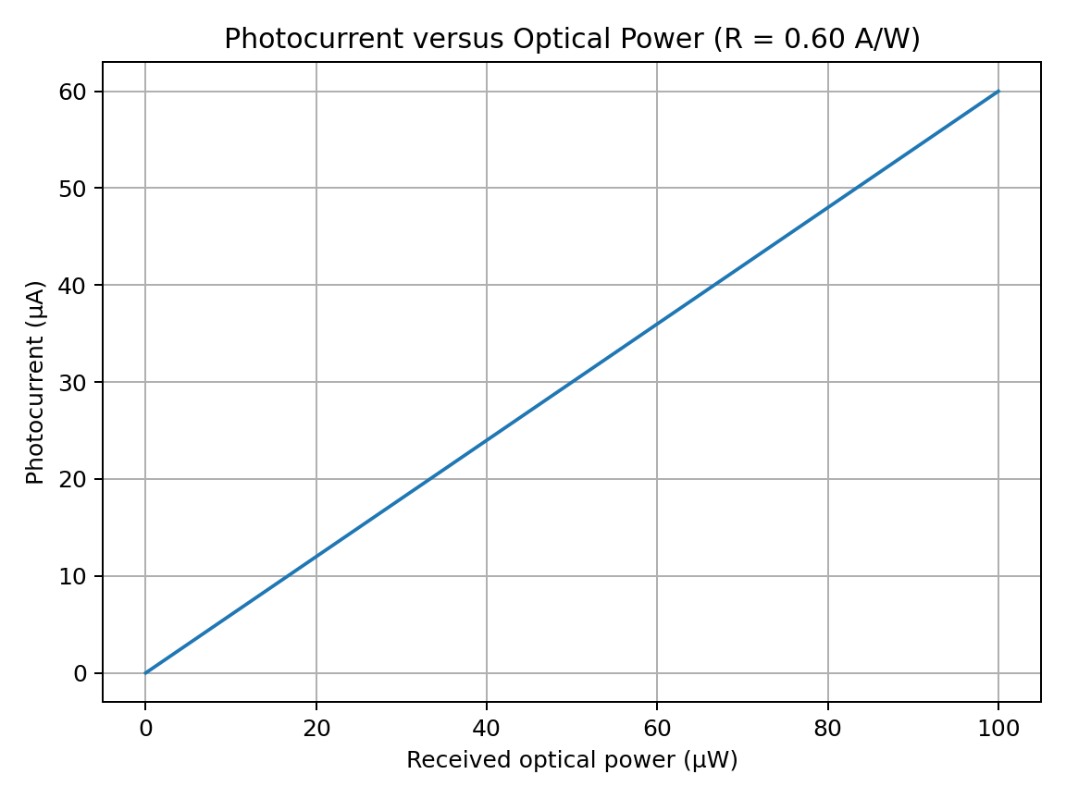
The curve follows Iph = RP. With R = 0.60 A/W, every 1 µW increase in optical power produces a 0.60 µA increase in photocurrent. At 25 µW, the model gives 15 µA, matching the hand calculation.

Illustrative SNR trend:
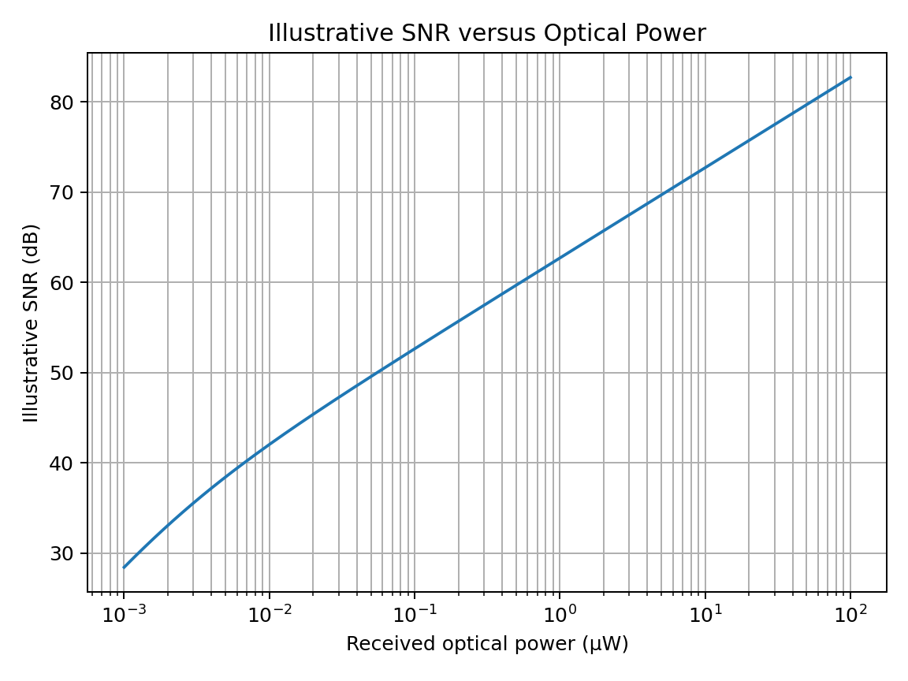
The plotted trend improves with optical power because the useful photocurrent rises above the assumed noise floor. Exact SNR depends on the detector, bandwidth, dark current, amplifier and signal definition. For the given dBm values, the separate calculation gives 15 dB.

MATLAB code:
% CO3 optoelectronics: photocurrent and illustrative SNR
clear; clc; close all;

R = 0.60; % responsivity (A/W)
P_uW = 0:1:100; % optical power (microW)
I_uA = R .* P_uW; % photocurrent (microA)
figure;
plot(P_uW, I_uA, 'LineWidth', 1.5);
grid on;
xlabel('Optical power (microW)');
ylabel('Photocurrent (microA)');
title('Photocurrent vs Optical Power');

% Illustrative shot-noise plus electronic-noise model
q = 1.602e-19;
B = 1e6; % bandwidth in Hz (assumed)
Id = 1e-9; % dark current in A (assumed)
i_e = 2e-12; % equivalent noise current in A (assumed)
P = logspace(-9, -4, 150);% optical power in W
I = R .* P;
i_shot = sqrt(2*q.*(I + Id).*B);
i_total = sqrt(i_shot.^2 + i_e.^2);
SNR = (I ./ i_total).^2;
SNR_dB = 10*log10(SNR);

figure;
semilogx(P*1e6, SNR_dB, 'LineWidth', 1.5);
grid on;
xlabel('Optical power (microW)');
ylabel('Illustrative SNR (dB)');
title('Illustrative SNR vs Optical Power');

% Given detector speed estimate
tr = 20e-12;
f = 0.44/tr;
fprintf('Transit-time bandwidth = %.2f GHz\n', f/1e9);

% Given SNR and PV maximum power
SNR_dB_given = -22 - (-37);
Pmax = 0.60 * 5 * 0.75;
fprintf('Given SNR = %.1f dB\n', SNR_dB_given);
fprintf('PV maximum power = %.2f W\n', Pmax);
Verification note: The theoretical values verified directly from the supplied data are 15 µA for the PPG photocurrent change, 2.4 µA for LiDAR photocurrent, 15 dB for the stated SNR, approximately 22 GHz for transit-time bandwidth, and 2.25 W for PV maximum power. The noise plot is assumption-based; it should not be described as experimental or device-specific validation.

Final System Verification
Requirement | Calculated / selected result | Status | Comment
PPG photocurrent change | 15 µA | Satisfactory for given data | Signal-conditioning and motion-artifact tests still needed
LiDAR photocurrent | 2.4 µA before APD gain | Satisfactory for given data | Actual range performance depends on optics and target reflectivity
Detector responsivity | 0.60 A/W PPG; 0.80 A/W LiDAR | Given | Values used directly in calculations
Quantum efficiency | Formula provided; wavelength missing | Needs data | Specify wavelength to calculate η
NEP / detectivity | Not numerically determined | Needs data | Noise spectral density and active area are missing
Low-light SNR | 15 dB (linear ratio ≈ 31.6) | Satisfactory for given data | Confirm under realistic noise and ambient-light conditions
Noise strategy | Filtering, low-noise amplifier, gain and bandwidth control | Proposed | Requires prototype measurement
Transit-time bandwidth | ≈22 GHz | Theoretical estimate | Circuit and parasitics may reduce total bandwidth
PV maximum power | 2.25 W | Calculated | Efficiency needs irradiance and cell area
Image sensor | CMOS | Selected | Suitable for compact low-power integration
Display | MicroLED for high-brightness near-eye use | Selected conditionally | OLED may be better for foldable cost-sensitive products
PPG / NIR / LiDAR / UV | Application-specific channels | Proposed | Needs wavelength and environmental testing
Face recognition | CMOS camera plus suitable illumination and software | Proposed | Requires privacy-aware software validation
Simulation | Photocurrent plot, illustrative SNR plot and calculations | Partially verified | Simulation assumptions must be replaced with measured component data

Final Integrated System Design

Proposed parameter table:
Subsystem | Proposed configuration | Reason
PPG | LED source + silicon PIN photodiode + low-noise transimpedance amplifier | Low power, low noise and sufficient response for pulse waveforms
NIR spectroscopy | Wavelength-selected NIR source + matched photodiode + optical filter | Supports wavelength-specific intensity measurement
LiDAR | Fast PIN or APD receiver; APD selected for weak returns if needed | Balances sensitivity, avalanche noise, timing and bias complexity
Imaging / face recognition | CMOS image sensor + image-processing SoC | Compact, fast and power-efficient integration
UV | UV-optimised photodiode + band-selective optical filter | Improves selectivity for the target UV band
Auxiliary power | Flexible PV + power-management circuit + storage | Provides supplemental power when illumination is available
Display | MicroLED for brightness-focused AR/VR/MR; OLED alternative for foldability | Decision depends on brightness, flexibility, manufacturing cost and lifetime
Simulation | MATLAB/SCILAB model with measured component data | Checks theoretical trends before prototype integration

Block diagram:
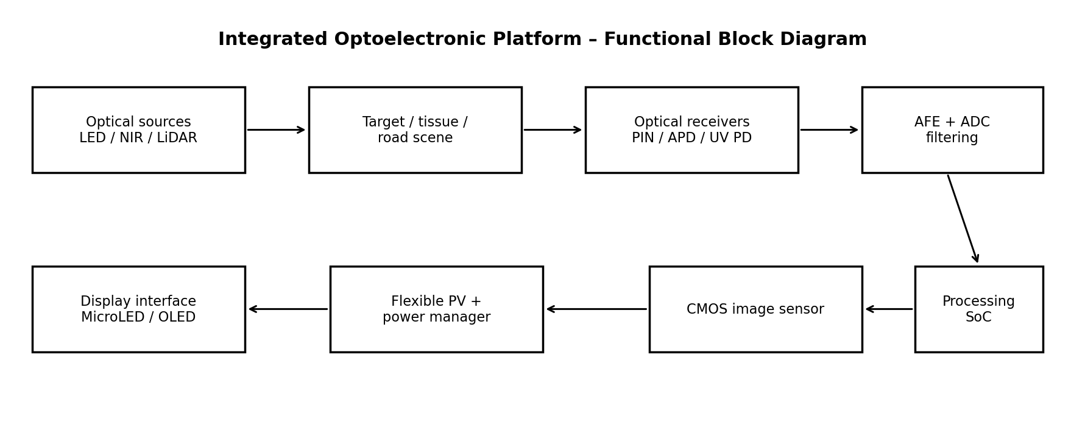
The diagram shows the major functional blocks. In a practical build, PPG, LiDAR, imaging and UV sensing would use separate optical paths and wavelength-appropriate components, while processing and power management may be shared where timing, safety and interference requirements allow.

Final Engineering Decision:
Decision: YES, with conditions. The proposed architecture is technically reasonable as a design concept because it uses detector types suited to the different tasks, obtains consistent values for the supplied calculations, and includes a path for simulation and system verification. The calculations give a PPG photocurrent change of 15 µA, LiDAR photocurrent of 2.4 µA, an SNR of 15 dB, a transit-time bandwidth estimate of 22 GHz and PV maximum power of 2.25 W.
The platform should not be deployed as a finished product until the missing parameters are measured or specified. In particular, quantum efficiency needs the operating wavelength; NEP and detectivity need noise and detector-area data; actual LiDAR range requires an optical link budget; PV output needs real illumination conditions; and display selection requires thermal, cost and mechanical testing. The MATLAB/SCILAB noise model is illustrative and must be updated using component datasheets and laboratory measurements.
The next engineering step is to build separate proof-of-concept modules, measure responsivity and noise over the intended bandwidth, validate the image and sensing pipelines, then integrate the modules and repeat the tests under realistic conditions.

Conclusion:
This report developed an application-specific optoelectronic platform rather than selecting one technology for every task. PIN photodiodes are recommended for low-noise PPG, APDs are considered for weak LiDAR returns, CMOS is selected for compact imaging, flexible PV provides supplementary energy, and MicroLED is preferred when high brightness is important. The given calculations are internally consistent, while the analysis also identifies missing information that prevents complete NEP, detectivity, quantum-efficiency and efficiency calculations. Simulation provides a useful first check, but final deployment requires measured component data, prototype testing and reliability validation.

References:
- S. M. Sze and K. K. Ng, Physics of Semiconductor Devices, 3rd ed., Wiley, 2007.
- B. E. A. Saleh and M. C. Teich, Fundamentals of Photonics, 3rd ed., Wiley, 2019.
- J. Wilson and J. F. B. Hawkes, Optoelectronics: An Introduction, 3rd ed., Prentice Hall, 1998.
- Hamamatsu Photonics, Si Photodiodes and APD technical information, manufacturer technical resources. Consult the selected device datasheet for final parameters.
- A. Rogalski, “Progress in focal plane array technologies,” Progress in Quantum Electronics, vol. 36, 2012, pp. 342–473.
- MathWorks, MATLAB documentation for plotting and numerical computation; use the version available in the laboratory.
- E. Hecht, Optics, 5th ed., Pearson, 2017.
Academic integrity note: This report is written specifically for the supplied assignment scenario in original wording. It should be reviewed, edited to reflect your own understanding, and supplemented with the exact datasheets and references required by your faculty. No document can guarantee a zero similarity score because technical terms, equations and standard definitions are commonly shared across engineering reports.

